The physical and technological barriers to education in the Mount Kenya region.

Introduction


In the shadow of Mount Kenya, the climb is not just physical; it is digital. While Nairobi buzzes with the title of 'Silicon Savannah,' earning its place as a global tech hub, a silent disconnect persists in the highlands. As a Computer Science student, I study the architecture of information systems—how data flows from a server to a client. But for thousands of students in our rural communities, that flow is severed not by a lack of intelligence, but by a lack of infrastructure. The path to the future is being paved with code, but many are still walking on dirt roads to find a signal.

The hardware Graveyard
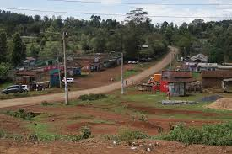

We speak of the cloud, but education here is grounded in the grit of outdated hardware. In many local schools, the ratio of students to computers is overwhelming. These machines, often second-hand donations from the West, struggle to run the modern software required for basic digital literacy. As a developer, I look at these systems and see the 8051 architectures of the past trying to decode the React-based web of the present. The enthusiasm of the students is boundless, but their tools are anchored in a bygone era.

The “Network” is Human
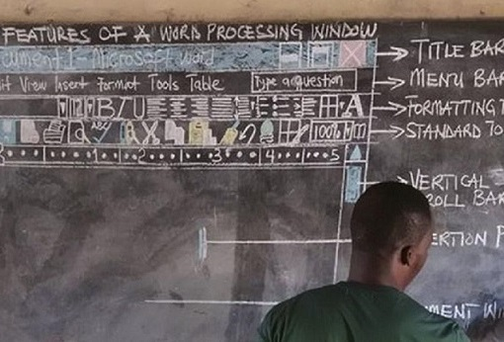

When the power fails, the network becomes human. I have witnessed teachers manually drawing website wireframes on blackboards, teaching the logic of CSS and layout without a single screen in the room. This is the definition of resilience. It challenges the 'Ethical AI' debate: how can we worry about algorithmic bias for a population that has not yet been granted basic algorithmic access? The true 'User Interface' here isn't a screen; it’s the dedication of an educator bridging the gap between theory and reality.

The Mobile Paradox
Yet, hope is mobile. Kenya’s mobile penetration is the great equalizer. Where fiber optics fear to tread, 4G signals occasionally wander. Students submit assignments via WhatsApp and research capstone projects on 5-inch screens. This 'Jua Kali' approach to education—innovating through scarcity—mirrors the logic of embedded systems: optimizing limited resources to achieve maximum output. The smartphone is no longer just a communication device; it is a library, a laboratory, and a lifeline.

The Call to Action
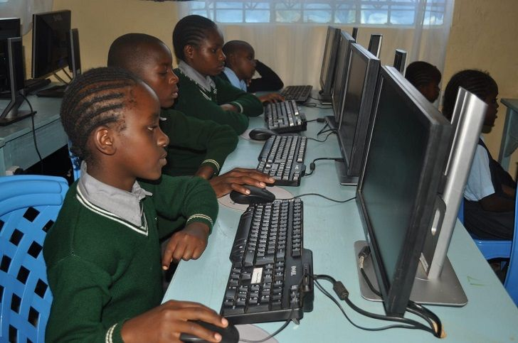

My journey in Computer Science has taught me that a system is only as good as its accessibility. Building an 'Online Student Clearance System' or a sophisticated website is meaningless if the users cannot reach the URL. As we push forward into an era of AI and automation, we must ensure we are not leaving a generation behind at the base of the mountain. The climb to the top requires more than just willpower; it requires a digital Sherpa—infrastructure, policy, and ethical engineering—to ensure that the view from the summit is shared by all.

